**Westpac Junior Landcare &**

**Bringelly Public School**

Student Sustainability Leadership Grant:

*Bird Survey and Habitat Restoration*

Performed by the BEES

(Bringelly Environmental Education Squad)

**Mission Statement:** *Our goal, as custodians of Bringelly Public School, is to restore a waterwise, drought tolerant Cumberland Plain Woodland habitat that is sustainable and protected within our school grounds. This will provide a refuge for many local species of birds, reptiles, amphibians and a wide range of invertebrates. This will ideally be a showpiece of biodiverse and sustainable practices within the community. We intend maintaining this habitat as an educational resource to teach eco-friendly environmental management skills to our students thereby arming them with the knowledge to reproduce similar projects in the wider community.*

**Grant:** $1650 (including GST)

**Purchases:**

* 134 Cumberland Plain Woodland plants
* 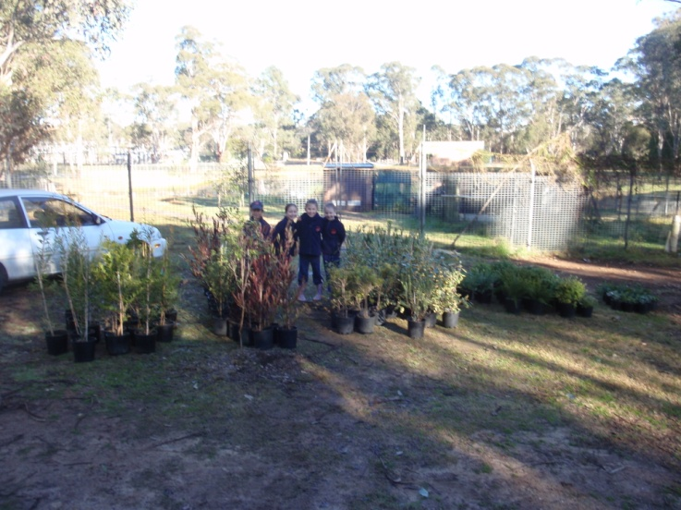Class set of long handled trowels
* 20 Native Bush Tucker plants
* Class set of weeding tools
* Tree guards & Stakes
* 5 mid-sized shovels
* 5 mid-sized spades
* Class set of Hoes
* Gypsum & Fertiliser
* Buckets

**Plants purchased with our grant**

**Results *(Thus far)*:**

National Tree Planting Day 2011 saw our student population of 120 children plant 324 native plants on our school grounds. In combination with our existing gardening tools, our grant-funded purchases, donations and loans from our local community we provided tools for each and every student.

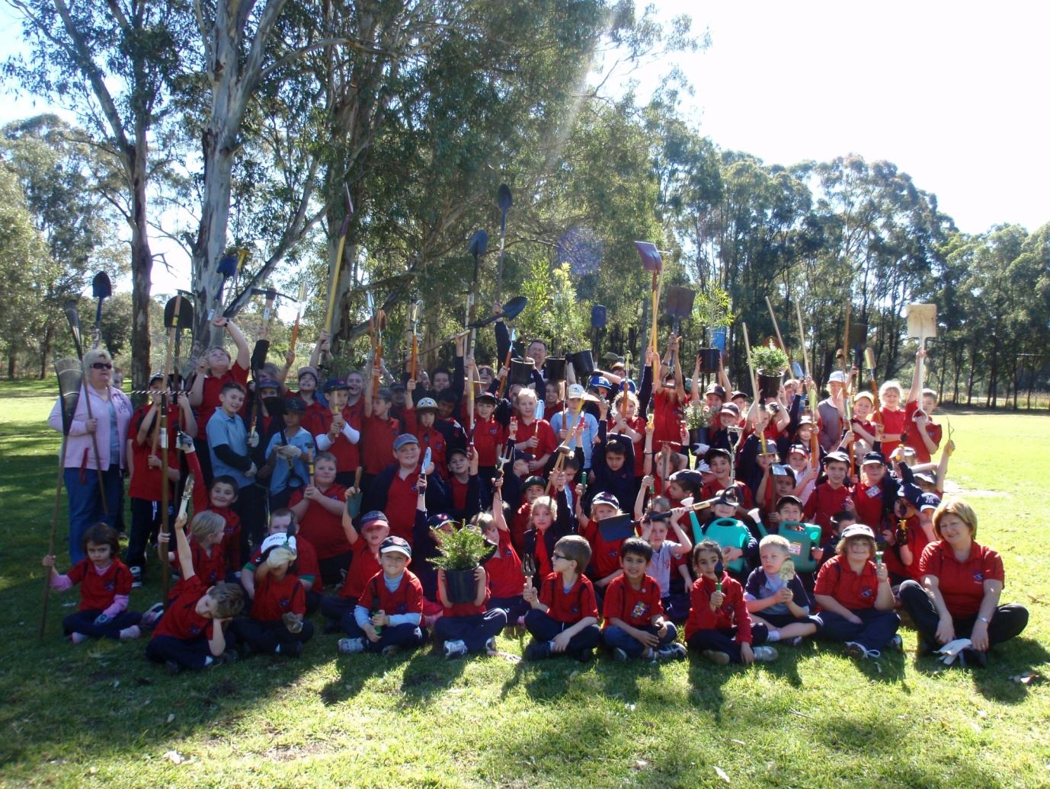

The Staff & Students of Bringelly Public School, Tree Planting Day

Furthermore, our student’s families donated over 90 plants for the project (Typically we receive fewer than 5 plants). What was planned for a morning session lasted an entire day with almost all of our senior students working voluntarily through lunch and recess. The enthusiasm shown was remarkable and this can be attributed to two main factors:

1) Our purpose. We knew what had to be done and why we were doing it. Feedback from Bush Regeneration consultants, Nursery staff and Birds Australia encouraged us to take a layering approach with plant selection and we bought a selection of 3m & 2m trees, 1m & 50cm shrubs and groundcovers. Many of these provide shelter or are food and nesting material sources for native birds. Our student leaders, using skills and knowledge acquired and built upon thus far in our project from environmental groups, mentor students and the local community, competently organised and managed most facets of the day. They managed and delivered resources, selected planting sites, organised prompt watering services, instructed and monitored the laying of recycled weed matting, and buddied-up with all of our junior students for the plantings passing on the skills we are developing.

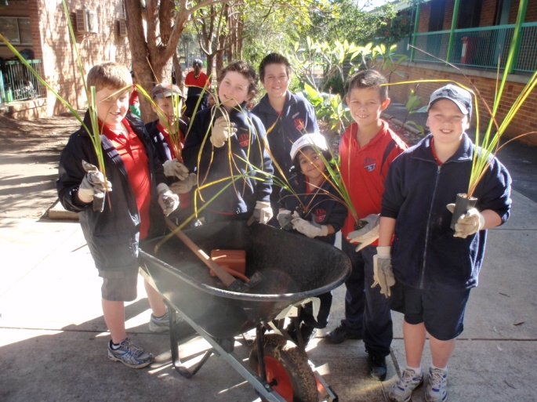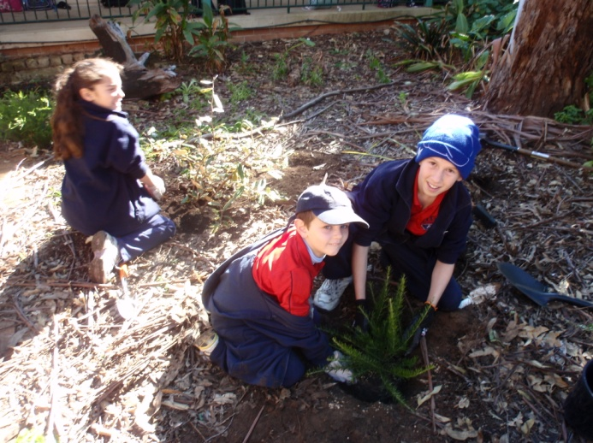

Student Leaders & Buddies on National Tree Planting Day

2) The scale of the project. The quantity of materials and plants allowed us to transform huge areas of our school grounds. Every garden bed (& several new ones) have benefitted from our efforts. This was only made possible by the funding provided from Westpac Junior Landcare. Our students, staff and P&C are truly appreciative.

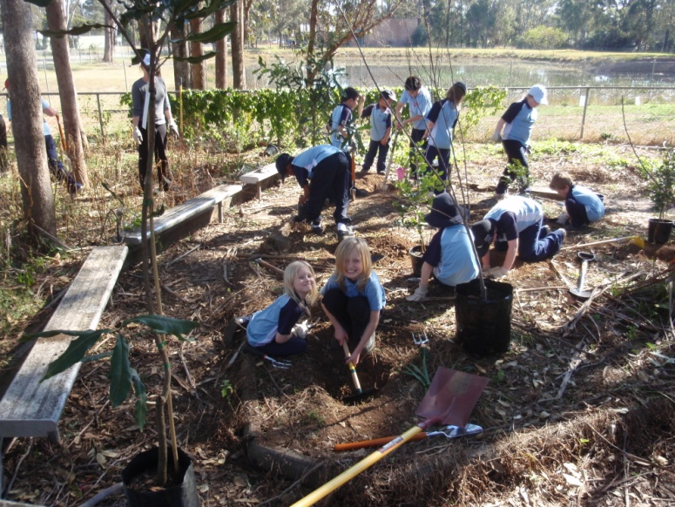

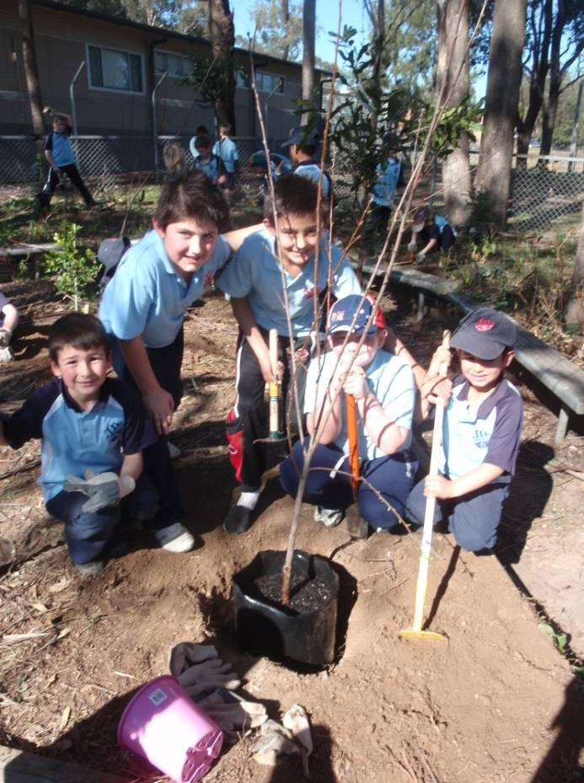

Student Leaders and Buddies

working on our Bush Tucker Garden

Before

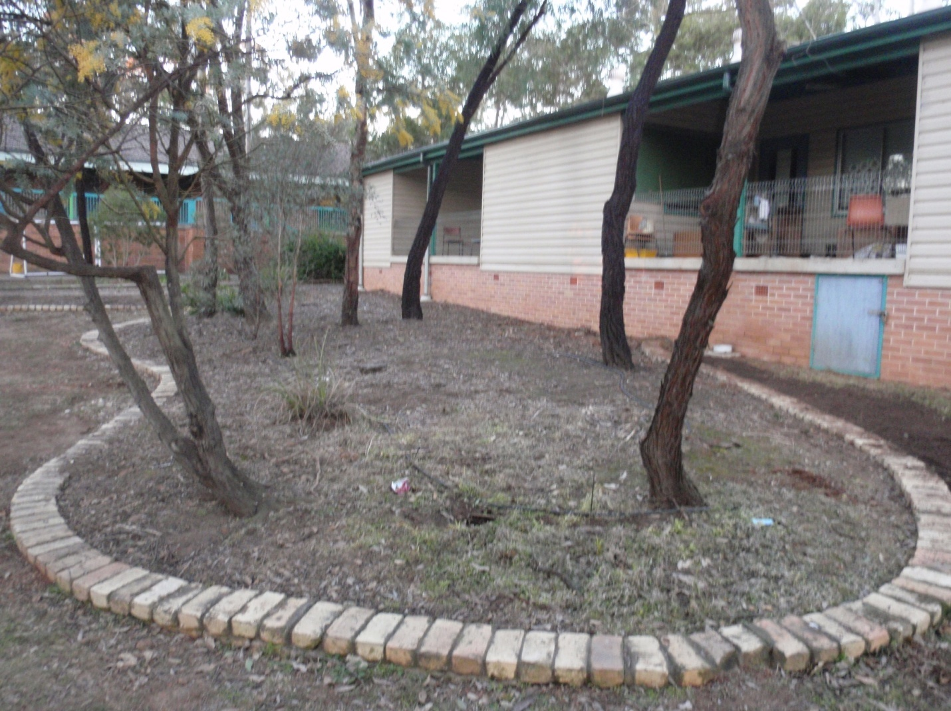

Before After

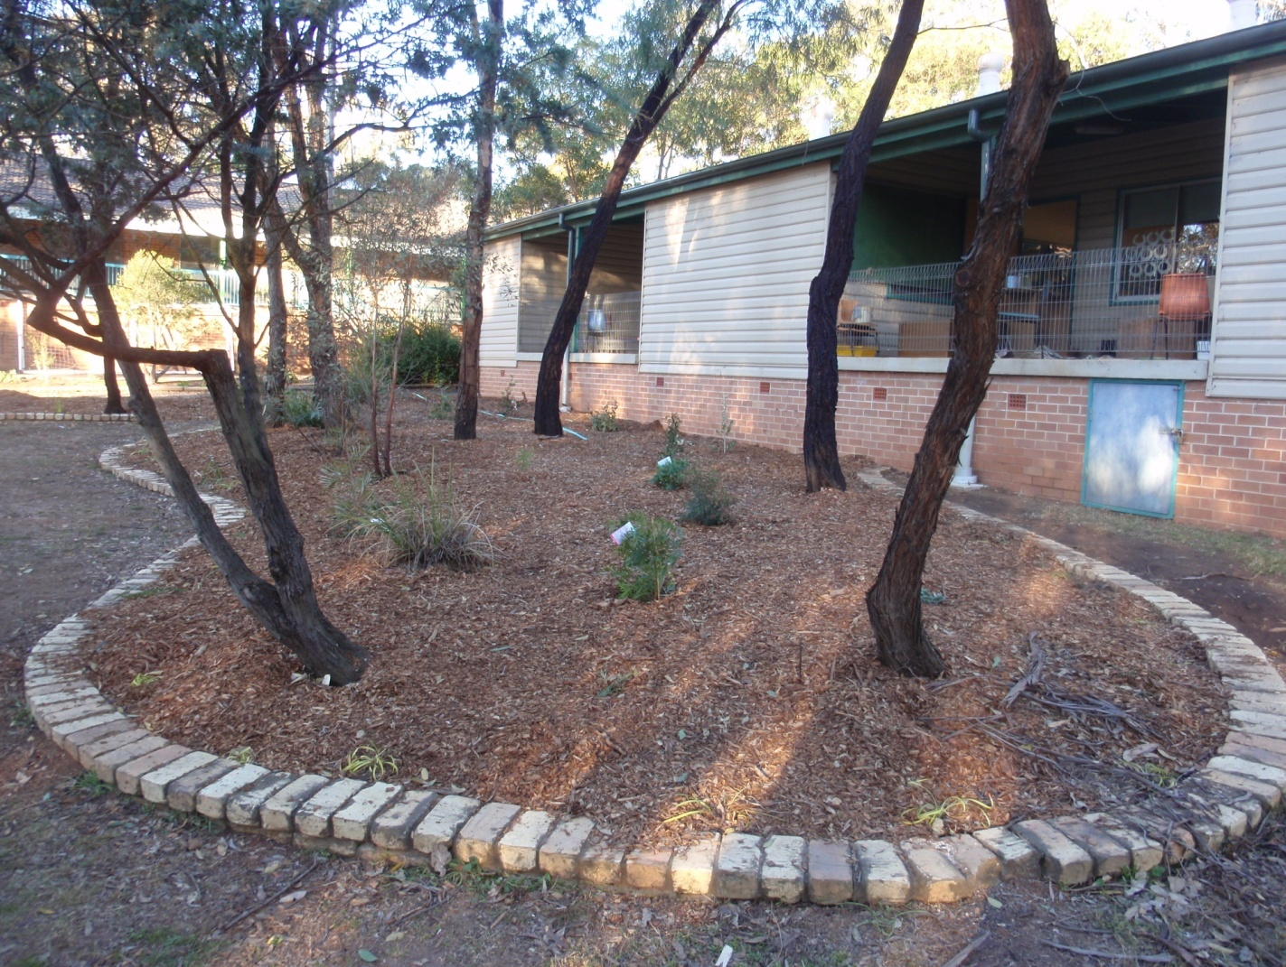After (with 80 extra trees, shrubs and grasses)

We intend building on this success by continuing our bird habitat restoration projects perpetually. We have a gardening club to monitor and maintain the environment and are regularly updating our sustainability action process by making the case for change, defining our scope for action, developing then implementing proposals and reflecting on the processes used and the learning. An example of this was identifying white-winged choughs in our weekly bird surveys (not seen in 2010). This was recognised as a forager and an infrequent visitor to our school. To encourage these visitations the proposal was made to increase forage space of leaf litter and mulch. This was implemented by transforming our veggie paddock pathways from grass to mulch. Our reflections show reduced mowing costs and reduction in greenhouse gasses as well as greater biodiversity potential. Conclusion, more mulch.

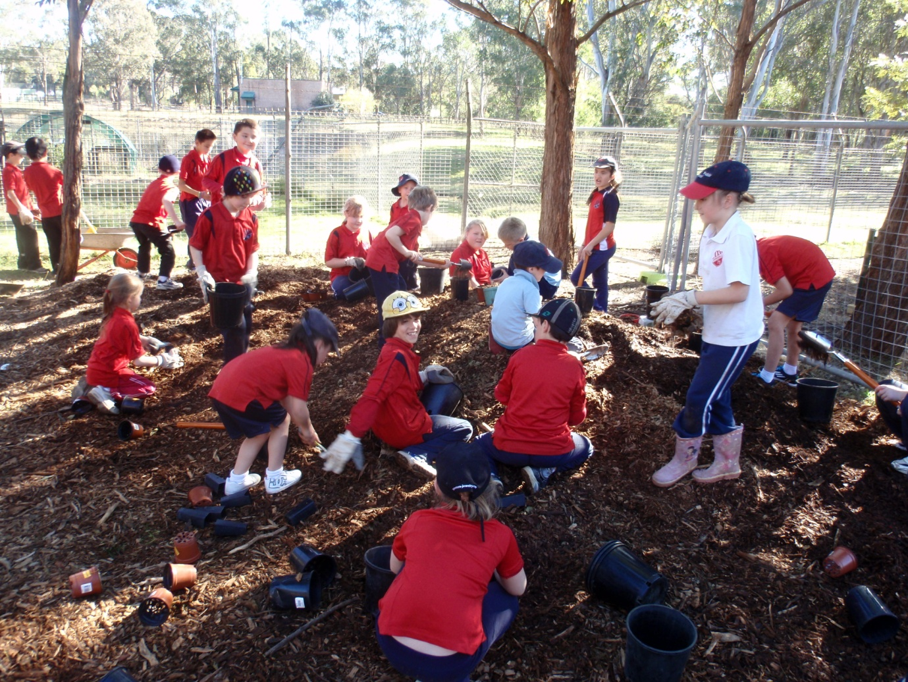

Busy BEES at work distributing mulch.

Our Bird Survey for 2011 has spotted 55 species of birds (up from 43 for all of 2010). This increase in varieties still shows limited visits from frugivores (fruit eaters) and nectarivores (nectar eaters). Our observations have led us to conclude there are three factors involved; 1) a lack of suitable fruiting trees, 2) limited layering of plants & 3) bullying by aggressive noisy miners.

We hope to have remedied this by 1) our planting of a bush tucker garden to provide fruiting trees including native plums & limes, 5 varieties of lillipillis and macadamia trees 2) over 300 new plants (154 purchased via the grant and 150 ┼ donated plants) providing multi layers of vegetation as they grow 3) grant plants were selected for mixed layers and sheltering suitability, i.e. spiky, bushy or thorny plants suitable for sheltering smaller wrens and finches, etc from the attentions of our bully birds. As our gardens grow we hope to see a more balanced diversity of birdlife.

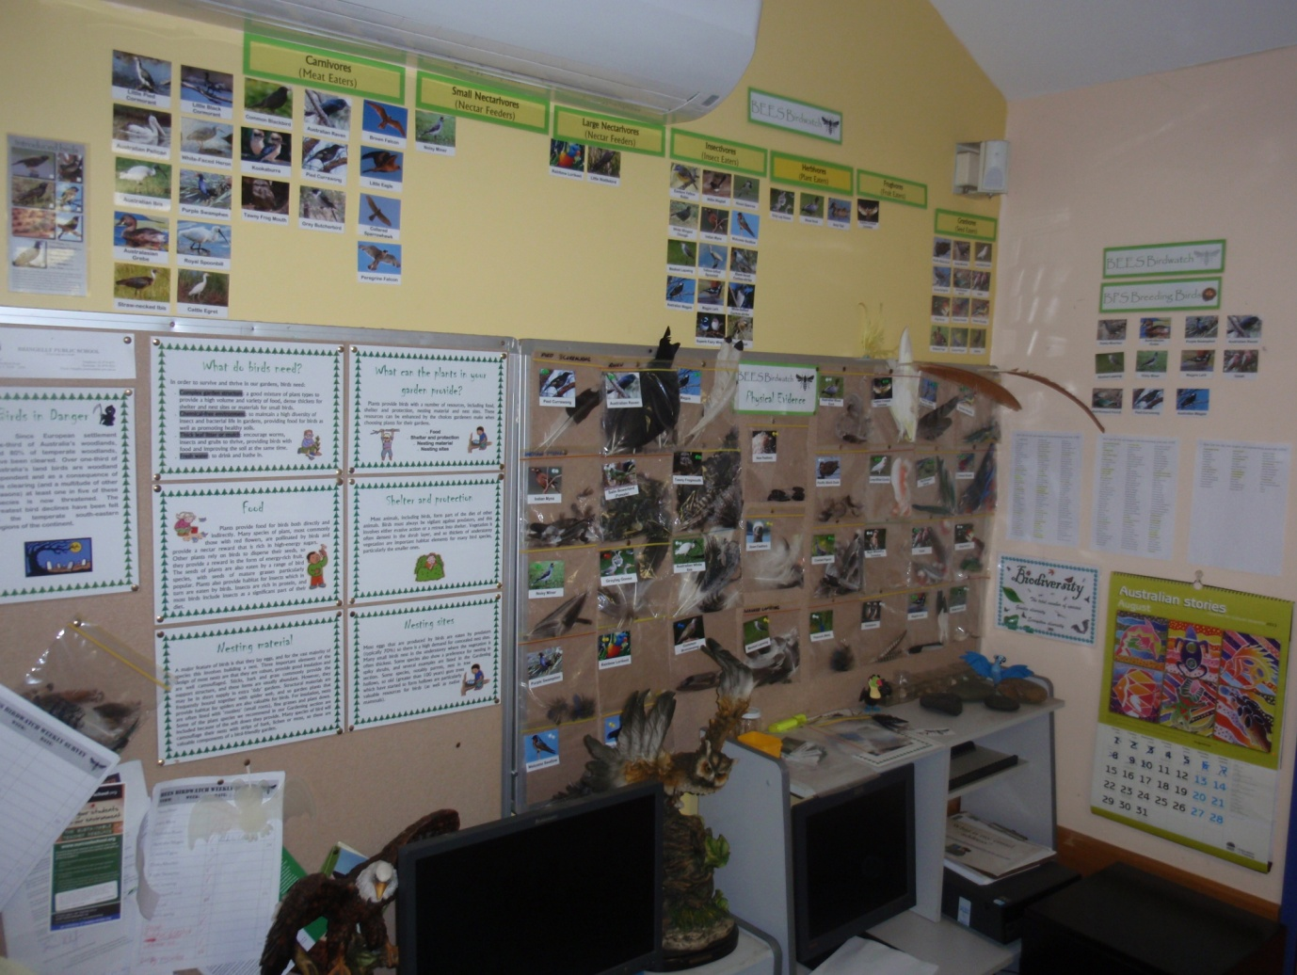

BEES Birdwatch Data and physical evidence display

We have feather samples from 34 birds that we compare with playground finds to identify bird visitors.

Our hopes are to extend our mentoring programs with our local high school by having their woodworking students construct and install nest boxes for us. This is to include a new home for a brush tailed possum currently abiding in one of our sheds. We are looking into donations or funding for this project.

With volunteer help we have constructed a causeway into our school dam and this has immediately impacted our water fowl diversity as we have had an increase in numbers and varieties of ducks now visiting.

Our school has funded the services of a Bush Regeneration Consultant & landscaper who has removed a vast amount of weeds from our grounds including a stand of privet bush. In conjunction with our ongoing plantings we are succeeding in returning our landscape to its roots of Cumberland Plains Woodland.

Our environmental program continues to be female dominated and this interest in the environmental sciences has transferred to other areas of science and technology. The girls are now taking the initiative in many investigations and frequently outperform the boys. This has led to increased participation rates in other extracurricular science activities including *Murder Under the Microscope* and sustainable energy usage.

We are now collecting and recycling soft drink bottles to use as building materials to repair our school greenhouse. We are also planning to reduce our rubbish production via the introduction of a No Rubbish Lunch (NRL) competition. These waste reduction initiatives are planned to demonstrate to the students and ultimately the wider community high quality sustainable practices. School rubbish surveys will be undertaken to gauge the effectiveness of this proposal.

Our goal, as the custodians of the landscape, has included the learning of improved values and attitudes towards a sustainable and biodiverse planet. Feedback from teachers, students and their parents is indicating that we are succeeding and that this is disseminating into the local community.

Greg McCroary

Class Teacher, 3/4M.

MC900053161[1]