William Brown
1894 – 3/9/1916
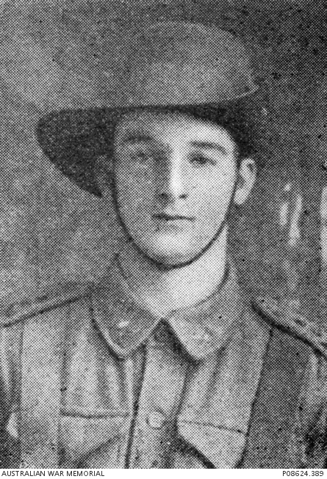
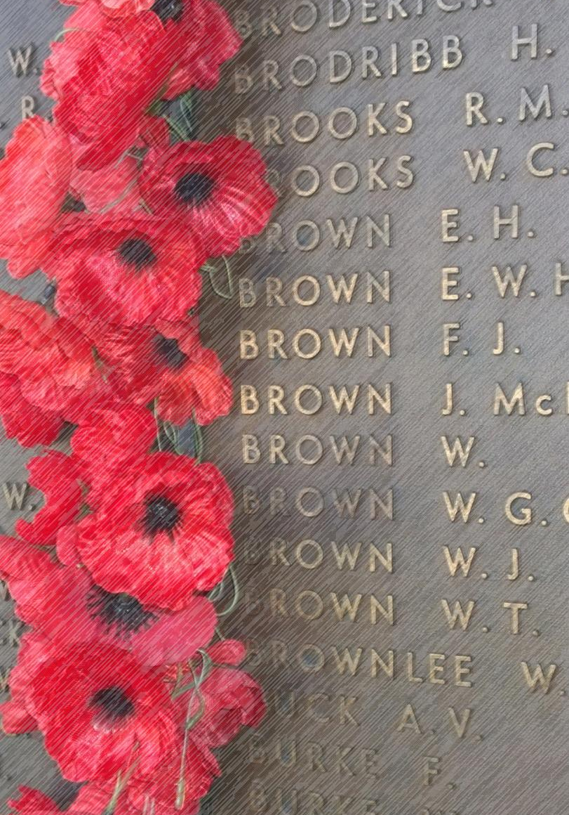

3rd September 1916
On the 3rd September 1916, 100 years ago tomorrow, a young man from our local area went in to battle at a small farm in France called Mouquet Farm. The Australian soldiers fighting in World War One called it ‘Moo Cow Farm’. And this was the ninth attack in 4 weeks to try to capture and hold the position. The ANZACs lost over 11,000 men killed or wounded during these battles and all of the battles failed to capture and keep the farm.
William Brown was a member of our local church parish. He was a butcher who was 21 years old when he joined and left home to fight in France during World War 1. He was a young man looking for fun and adventure. His boat left Sydney in July 1915. It stopped in Perth, Western Australia and William, with some mates got off and went sightseeing to have some fun. Like many young people William wasn’t perfect. He was late and missed the boat when it sailed to Europe. For this he was confined to quarters for 14 days and fined four weeks’ pay.
Returning to the war, he was promoted to Corporal within a few months and by April 1916 he had been promoted to Sergeant. By August he had been promoted again and was a 2nd lieutenant. He had proved he was brave and could be a leader of men in a machine gun section. He was recommended for a medal for bravery after a battle at Mouquet Farm on the 14th August.
His citation reads; “For bravery and coolness near Mouquet Farm during a night attack August 14th to 15th 1916. This NCO organised and linked up parties to dig in and held them there by dint of cheerful example. He also assisted in getting wounded into safety and bandaged up one officer while under heavy fire.”
William, for his bravery, was awarded the Military Medal, but he never knew it. While attacking Mouquet Farm again on the 3rd September he was killed. The attack was another costly failure and William’s body was never recovered. He has no known grave.
What was it like to fight at Mouquet Farm? Charles Bean, in his official Government history of World War One , devoted three chapters to this four week struggle during which thousands of Australians tried to push the British line forward a few hundred metres to capture the farm. Bean wrote:
“The reader must take for granted many of the conditions – the flayed land, shell–hole bordering shell–hole, corpses of young men lying against the trench walls or in shell–holes; some – except for the dust settling on them – seeming to sleep; others torn in half; others rotting, swollen and discoloured.”
Add to this terrible picture endless weariness, lack of sleep, hours of constant enemy shelling, the exertion of bringing up of food and supplies, the long muscle–wrenching carry involved in bringing out the wounded, and the endless digging to repair blown–in trenches and make new ones.
William has a monument for him on Bringelly Road, a memorial plaque and horse water trough now at the water canal next to Cowpasture Road. William was also remembered by his Parish of Bringelly/Rossmore with his name on the district honour roll and a memorial tablet in marble dedicated by his parents saying; ‘In loving memory of our beloved son, Lieut. Brown, M. M., 51st Battalion, A.I.F., who fell at Mouquet Farm, France, on 3rd Sept., 1916, aged 22 years. A noble life that promised well.'
Today, nearly 100 years after the battle we remembered that noble life that promised well. We remembered his bravery and sacrifice so that we could live in freedom. Today we flew our flags at half-mast and observed a minute’s silence to remember the men like William Brown, and their families.
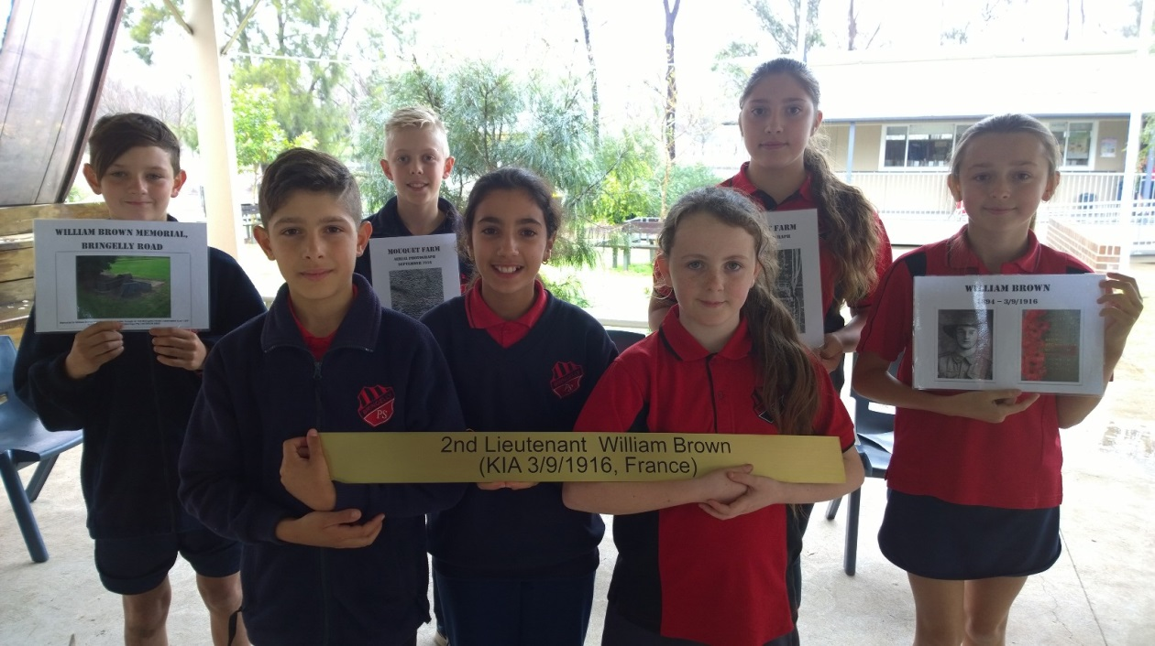

V

Mouquet Farm
Aerial Photograph
June 1916
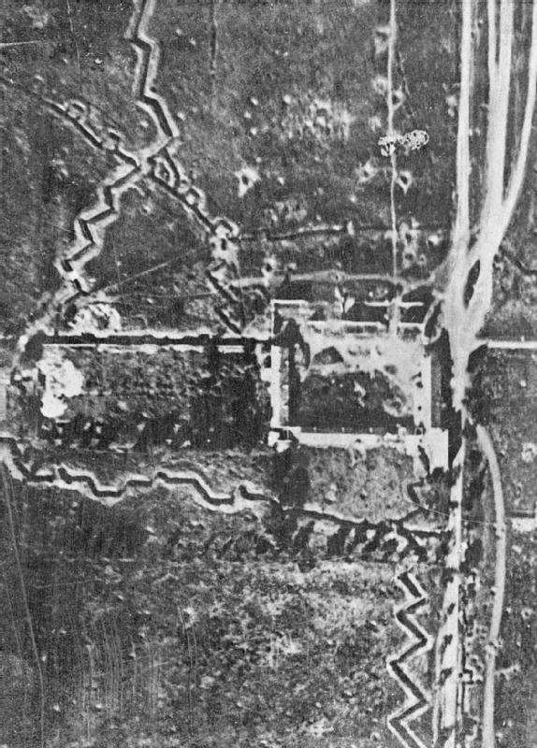

Mouquet Farm
Aerial Photograph
September 1916

