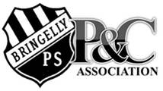
Bringelly Public School
P & C Association

14/11/22
P&C Fundraising
At the P&C meeting held Wednesday November 9, 2022 the P&C presented a fantastic idea for some new playground equipment. These are just some sample shots taken from the company’s website. These won’t necessarily be the cubby houses we purchase but it gives you a great idea about what they are aiming for. The school is very excited as these will present a great imaginative range of outdoor play opportunities for our students.
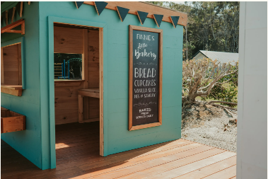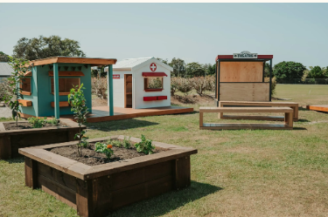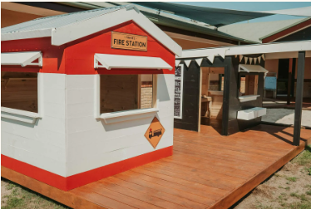
Of course to purchase such cool outdoor equipment the P&C must raise funds, so as a part of the end of year fund raising events the P&C will be hosting a range of events culminating in a Monster Raffle.
The first of which is a Mufti-Day Wed Nov 23, all students are asked to come in Mufti clothes and bring in non-perishable food items which can be placed into hampers for the monster raffle. Some great suggestions for food items might include;

- Christmas decorations
- Chocolates
- Tinned foods
- Biscuits
- Chips / crackers
- Jars -preserves/pickled items
- Tea
- Coffee
- Fruit cake/ plum pudding
- Nuts
- Jams
- Or something else we’ve not thought of

All donations will be greatly appreciated and the funds raised will help our P&C with the purchase of new playground equipment for all our students to enjoy.
Because these hampers will be assembled and stored at the school until the raffle (Presentation day) we ask that anything donated not require refrigeration or have a short expiry date.
To support the monster raffle the school is currently seeking support from community members and community businesses to donate prizes for our raffle and it is hoped we will be able to share our online ticketing process very soon once all the prizes have been sorted. We have already had a brand new iPad (10th generation) donated from a very generous family (Thank you Norman family!)
The P&C will also be holding a school evening Christmas themed disco on Friday December 9, 2022 with a BBQ meal deal. Students will be able to play games, spend time with friends and celebrate the end of the school year.
We are excited that we can again have school functions and activities and will send home notes before each event.
P and C Committee 2022.

Tamara Norman, Ashlee Brennan, Brett Norman and Zahera Perwaiz.

