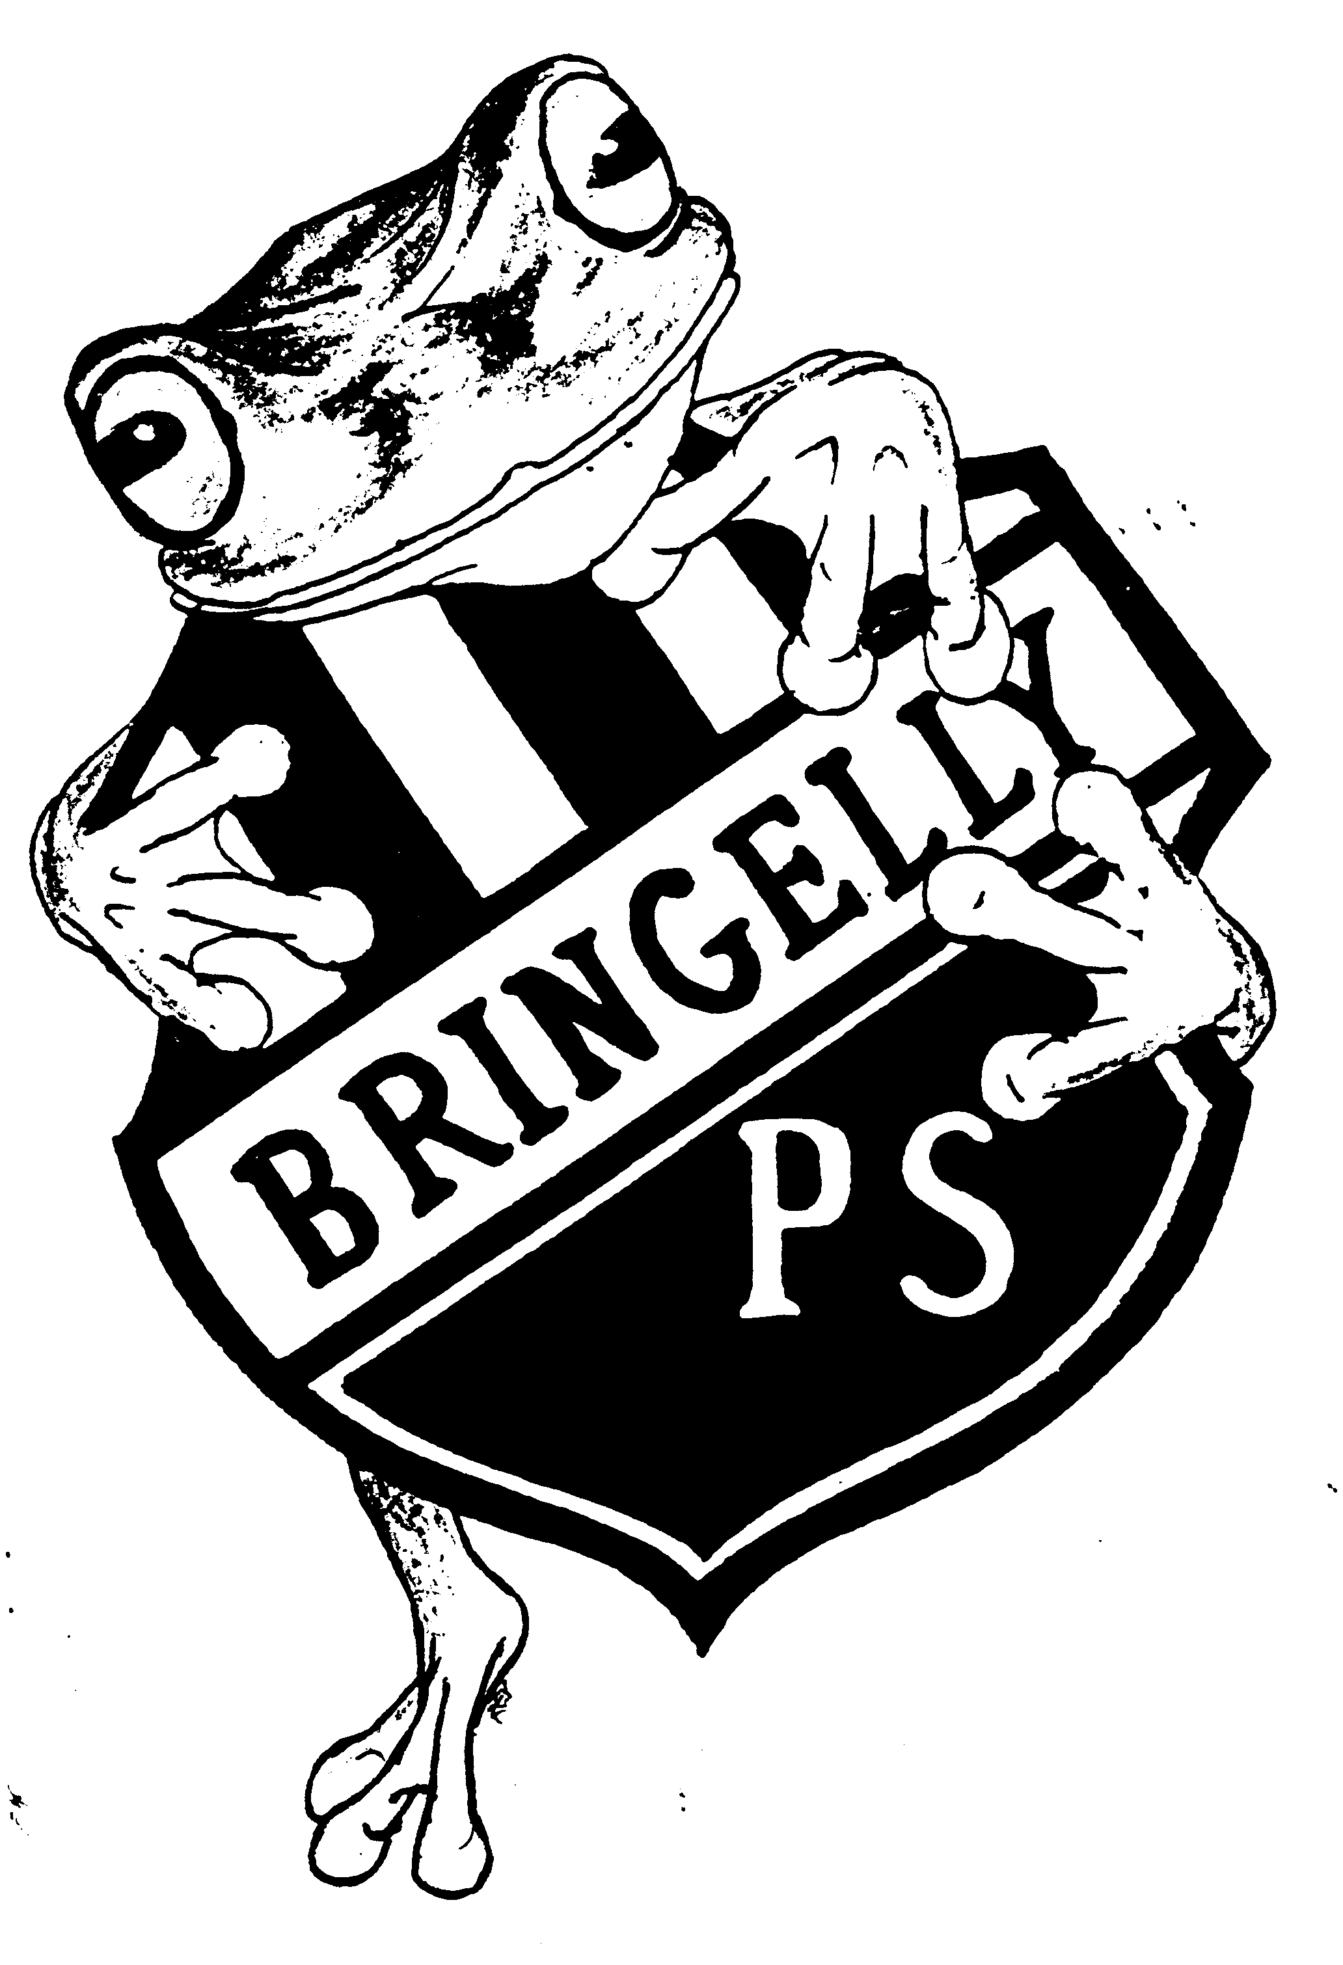
BRINGELLY PUBLIC SCHOOL
“TOGETHER WE GROW"

PO Box 103
1205 The Northern Road
BRINGELLY NSW 2556
Telephone: 02 4774 8271
Facsimile: 02 4774 9202
Email: bringelly-p.school@det.nsw.edu.au

Tuesday, 11 February 2020

BEHAVIOUR REWARDS SYSTEM UPDATE

Dear parents/caregivers,
The staff at Bringelly conduct a review each year to ensure we are providing a quality learning environment for all students. After reviewing the behaviour reward system we have decided to make a slight modification in 2020. Previously students were tracked over a two year period and they were required to hold onto awards over that period in order to gain higher level rewards. The staff have decided that this can mean that some students who are hardworking and conscientious will ultimately miss out because they may have joined the school mid-way through the two year cycle, or they may have miss placed awards due to circumstances beyond their control. To redress this balance the staff have decided to move to a system that goes for one year only. What this means is that each child will work towards the higher level award from year to year instead of over 2 years. We realise this would make beyond the banner unattainable for all students so to accommodate this change we have removed some levels, the new levels will be
10 merit awards - Bronze
Bronze + 10 merit awards – Silver
Silver + 10 merit awards – gold banner award
The gold banner level will be the level at which students will be invited for the special celebration events such as the excursion.
As we know this is a new system and may need adjustments the staff will monitor and make minor tweaks as the year progresses.
What this means for our students? All students who may have left over awards at home from last year can bring them in this week to receive any outstanding awards such as diamond or banner from 2019. These awards need to be returned this week so that they can receive their outstanding award at next week’s assembly. After next week’s assembly we will only be accepting awards from 2020 to go towards the new bronze, silver and gold banner.
We thank you for your cooperation during this time of transition, if you have any enquires please feel free to speak with your child’s teacher.

Sharyl Scott
Principal
Bringelly Public School

